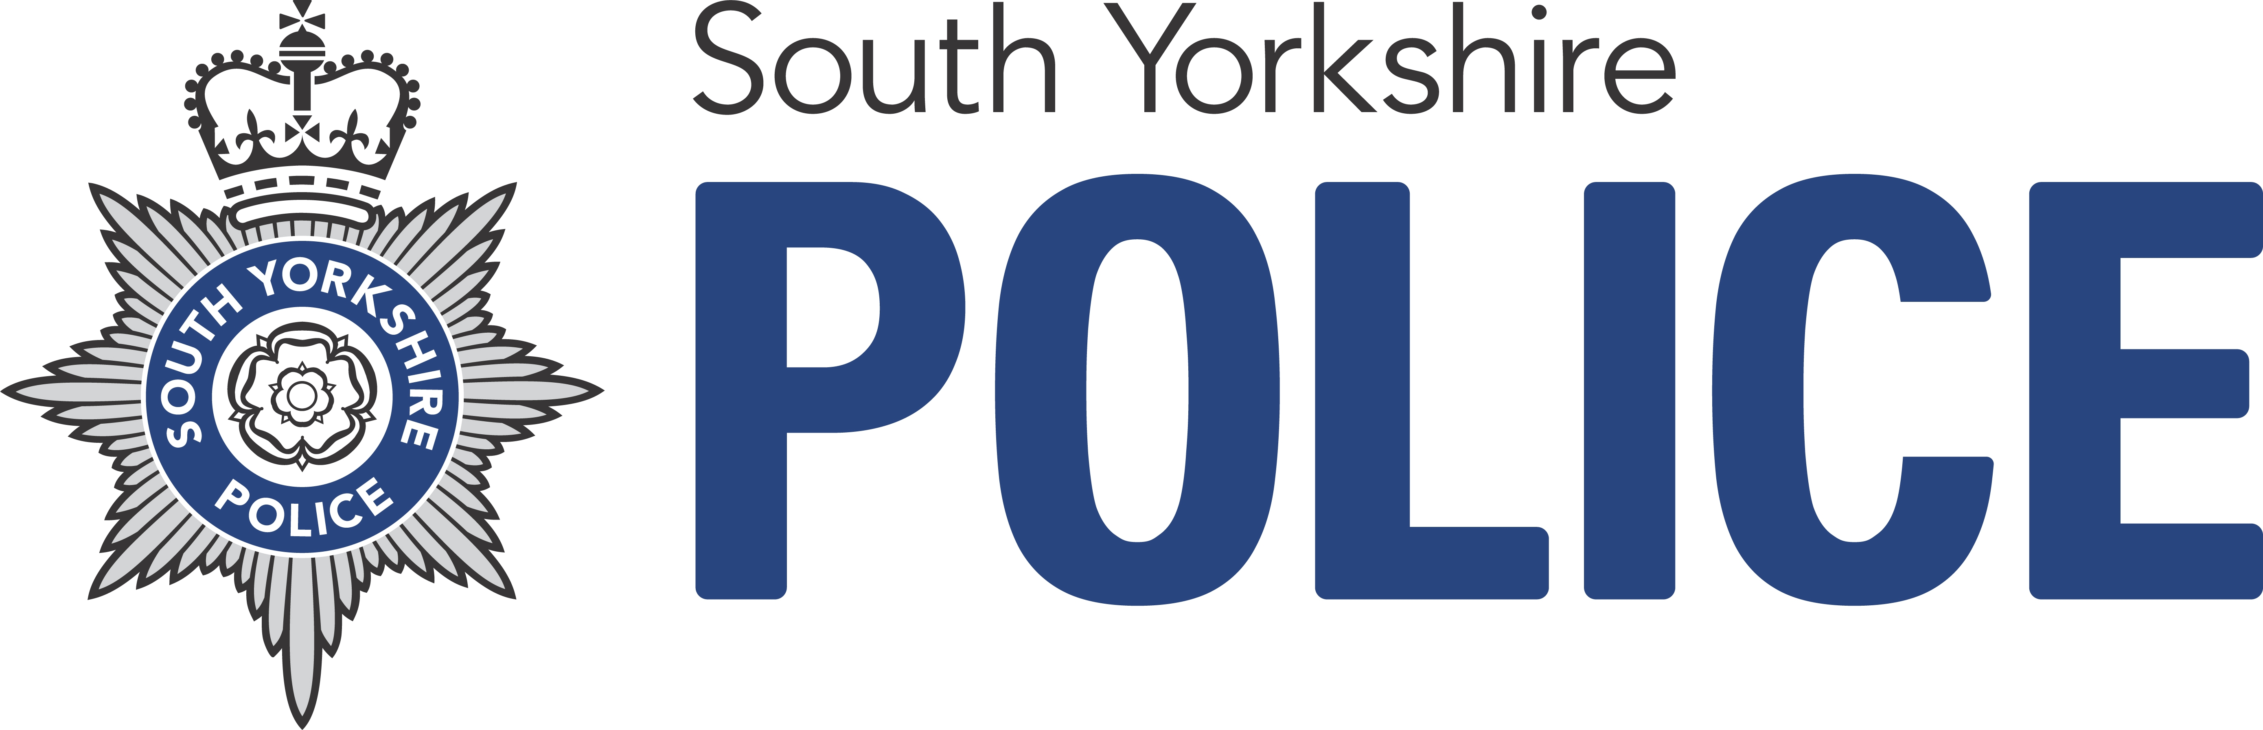

Sheffield South West Local Policing Team

Dear Resident

We would like to invite you to the next Police Community Safety Meeting to be held at the Madina Mosque on Tuesday 17th May 2016 at 7.15pm. The meeting will be in the community centre at the rear of the mosque on Glover Rd

The meeting will be attended by Inspector Ian Stubbs who is responsible for the staffing of Police resources in the Abbeydale and Sharrow Areas. It will also be an opportunity to discuss issues with local councillors

This meeting is to discuss any Anti-Social Behaviour issues in the area, to find out what the Police are doing and to discuss and other community safety issues.

If you would like to talk to anyone about the sale and supply of illegal drugs, ASB or any other matter of concern please contact any Police Officer/Police Community Support Officer at your Sheffield South Safer Neighbourhood Team on 101 or telephone Crime stoppers on 0800 555 111. Any information will be treated in the strictest confidence and you do not have to leave your name.

Information about Sheffield South Safer Neighbourhood team can be obtained via our website:
http://neighbourhood.southyorkshire.police.uk/sheffield/gleadless-woodseats

 Sheffield South West LPT.
KEInspector@twitter.com



